**PIZZA SALES SQL QUERIES**

**A. KPI’s**

**1. Total Revenue:**

SELECT SUM(total_price) AS Total_Revenue FROM pizza_sales;

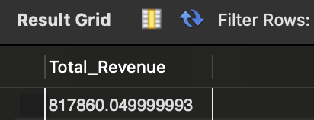

**2. Average Order Value**

SELECT (SUM(total_price) / COUNT(DISTINCT order_id)) AS Avg_order_Value FROM pizza_sales;

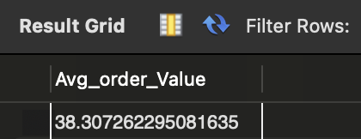

**3. Total Pizzas Sold**

SELECT SUM(quantity) AS Total_pizza_sold FROM pizza_sales;

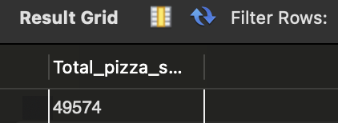

**4. Total Orders**

SELECT COUNT(DISTINCT order_id) AS Total_Orders FROM pizza_sales;



**5. Average Pizzas Per Order**

SELECT ROUND(SUM(quantity)/COUNT(DISTINCT order_id,2) AS Average_Pizzas_Per_order

FROM pizza_sales;



**B. Daily Trend for Total Orders**SELECT DAYNAME(order_date) AS order_day, COUNT(DISTINCT order_id) AS total_orders

FROM pizza_sales

GROUP BY DAYNAME(order_date);

***Output:***

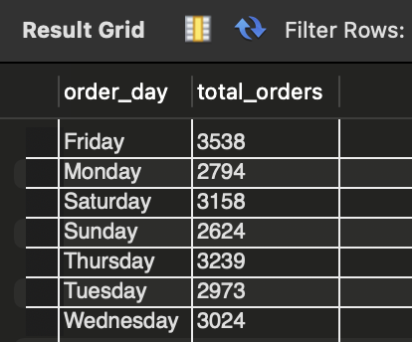

**C. Monthly Trend for Orders**

select MONTHNAME(MONTH, order_date) as Month_Name, COUNT(DISTINCT order_id) as total_orders

from pizza_sales

GROUP BY MONTHNAME(MONTH, order_date);

***Output***

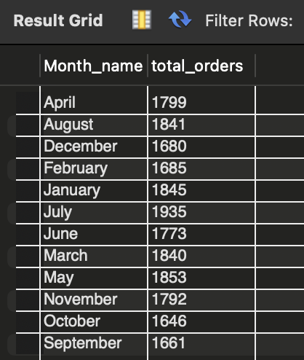

**D. % of Sales by Pizza Category**

SELECT pizza_category, ROUND(SUM(total_price),2) as total_revenue,

ROUND(((SUM(total_price),2) * 100 / (SELECT SUM(total_price) from pizza_sales)),2) AS PCT

FROM pizza_sales

GROUP BY pizza_category;

***Output***

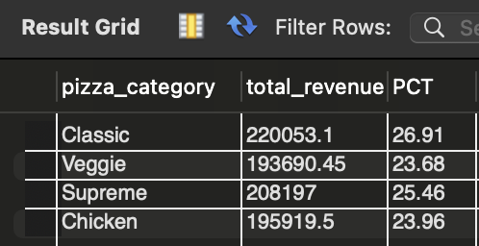

**E. % of Sales by Pizza Size**

SELECT pizza_size, ROUND(SUM(total_price),2) as total_revenue,

ROUND(((SUM(total_price),2) * 100 / (SELECT SUM(total_price) from pizza_sales)),2) AS PCT

FROM pizza_sales

GROUP BY pizza_size;

ORDER BY pizza_size

***Output***

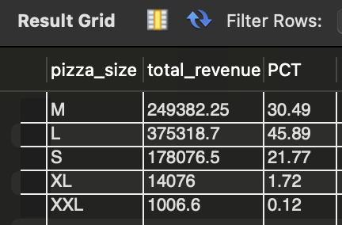

**F. Total Pizzas Sold by Pizza Category**

SELECT pizza_category, SUM(quantity) as Total_Quantity_Sold

FROM pizza_sales

GROUP BY pizza_category

ORDER BY Total_Quantity_Sold DESC

***Output***

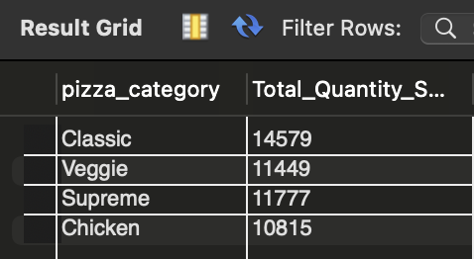

**G. Top 5 Pizzas by Revenue**

SELECT pizza_name, SUM(total_price) AS Total_Revenue

FROM pizza_sales

GROUP BY pizza_name

ORDER BY Total_Revenue DESC

LIMIT 5;

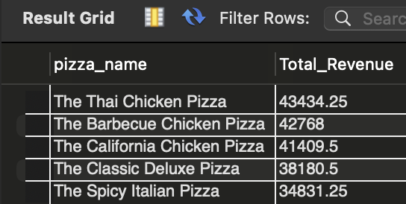

**H. Bottom 5 Pizzas by Revenue**

SELECT pizza_name, SUM(total_price) AS Total_Revenue

FROM pizza_sales

GROUP BY pizza_name

ORDER BY Total_Revenue ASC

LIMIT 5;

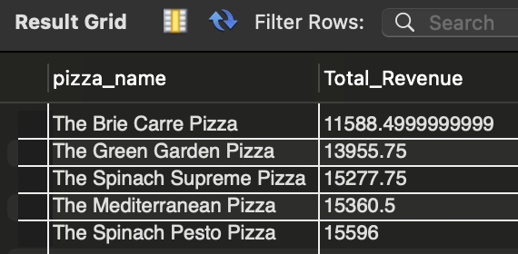

**I. Top 5 Pizzas by Quantity**

SELECT pizza_name, SUM(quantity) AS Total_Pizza_Sold

FROM pizza_sales

GROUP BY pizza_name

ORDER BY Total_Pizza_Sold DESC

LIMIT 5;

***Output***

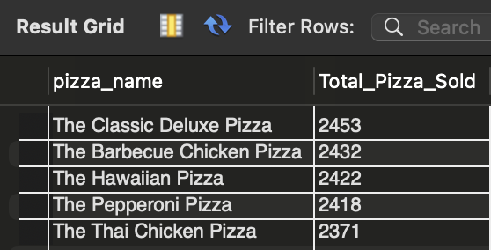

**J. Bottom 5 Pizzas by Quantity**

SELECT pizza_name, SUM(quantity) AS Total_Pizza_Sold

FROM pizza_sales

GROUP BY pizza_name

ORDER BY Total_Pizza_Sold ASC

LIMIT 5;

***Output***

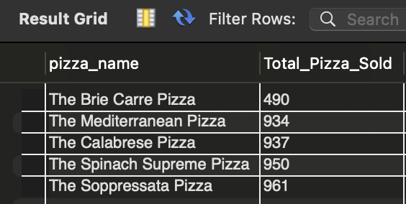

**K. Top 5 Pizzas by Total Orders**

SELECT pizza_name, COUNT(DISTINCT order_id) AS Total_Orders

FROM pizza_sales

GROUP BY pizza_name

ORDER BY Total_Orders DESC

LIMIT 5;

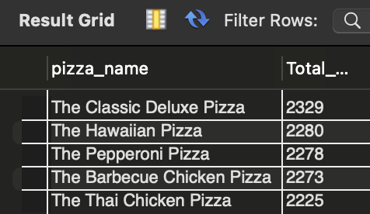

**L. Borrom 5 Pizzas by Total Orders**

SELECT pizza_name, COUNT(DISTINCT order_id) AS Total_Orders

FROM pizza_sales

GROUP BY pizza_name

ORDER BY Total_Orders ASC

LIMIT 5;

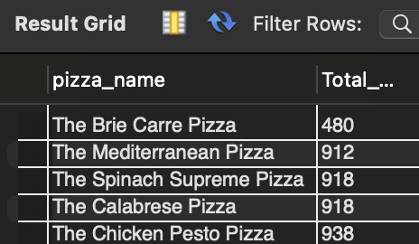

***NOTE***

If you want to apply the pizza_category or pizza_size filters to the above queries you can use WHERE clause. Follow some of below examples

SELECT pizza_name, COUNT(DISTINCT order_id) AS Total_Orders

FROM pizza_sales

WHERE pizza_category = 'Classic'

GROUP BY pizza_name

ORDER BY Total_Orders ASC

LIMIT 5;